Name: Meet Vipul Gandhi

PRN No: 2020BTECS00112

**High Performance Computing Lab**

**Practical No. 9**

**Title of practical:** Implementation of Matrix-matrix Multiplication (global and shared Memory), Prefix sum, 2D Convolution using CUDA C

**Problem Statement 1:**

Implement Matrix-matrix Multiplication using global memory in CUDA C. Analyze and tune the program for getting maximum speed up. Do Profiling and state what part of the code takes the huge amount of time to execute.

**Screenshots:**

1. <<<1,64>>>

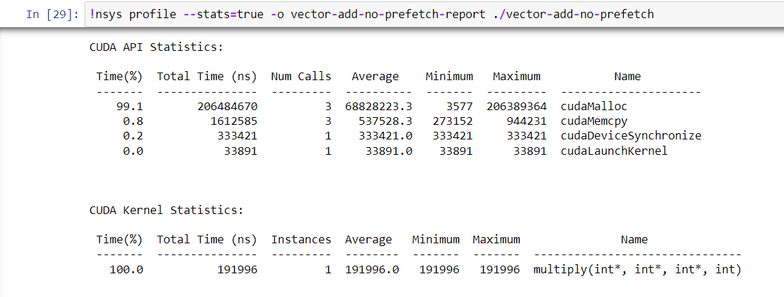

1. <<<1,128>>>

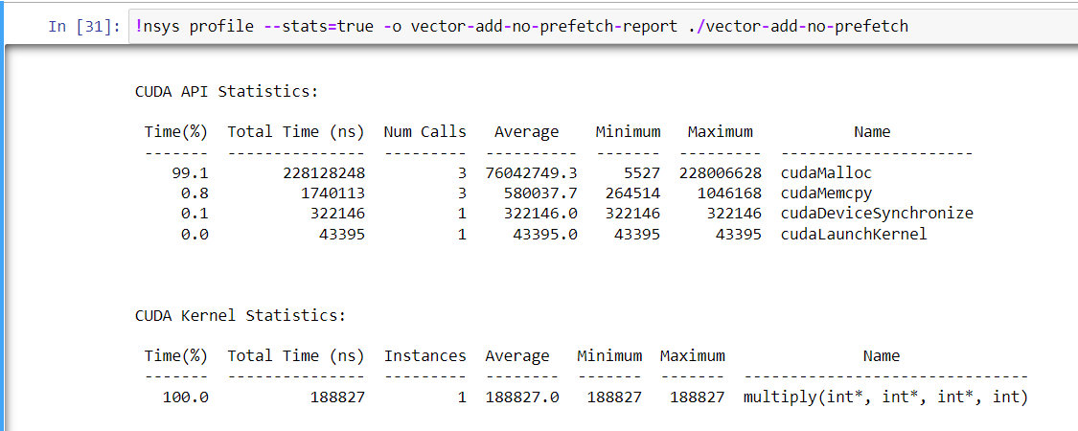

1. <<<1,256>>>

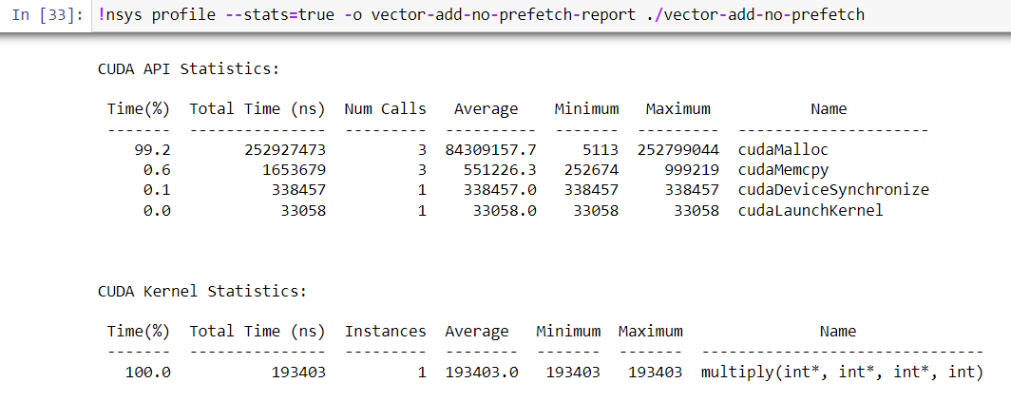

1. <<<2,64>>>

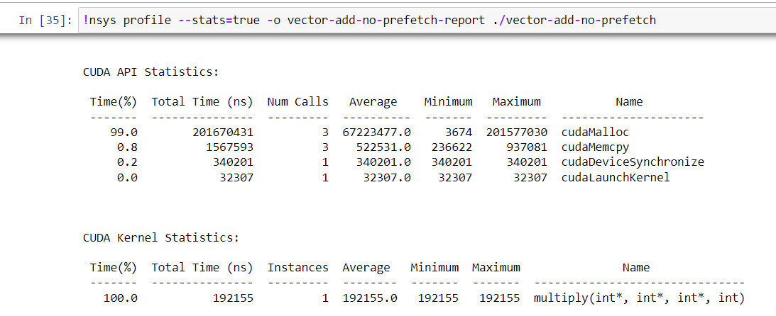

1. <<<2,128>>>

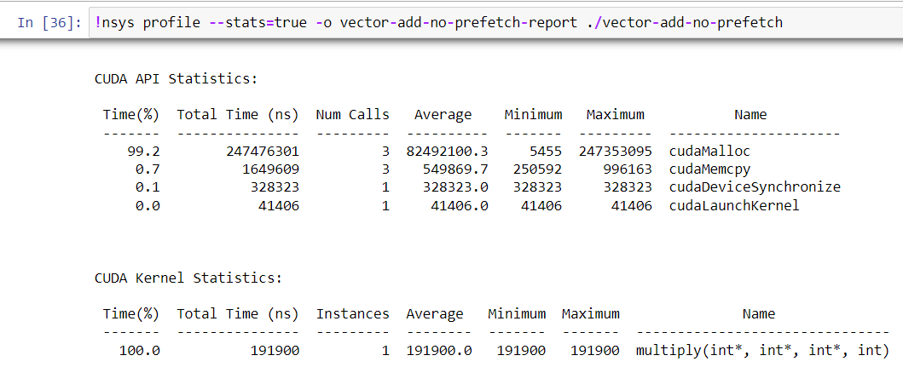

1. <<<4,64>>>

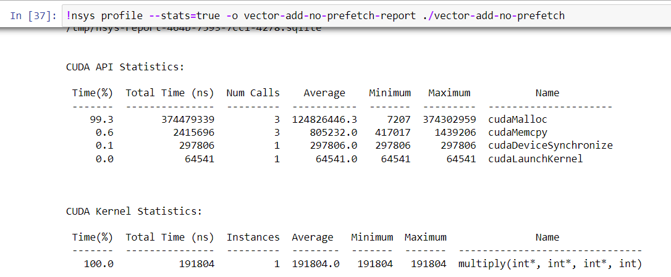

**Analysis:**

**Problem Statement 2:**

Implement Matrix-matrix Multiplication using shared memory in CUDA C. Analyze and tune the program for getting maximum speed up. Do Profiling and state what part of the code takes the huge amount of time to execute.

**Screenshots:**

1. <<<1,64>>>

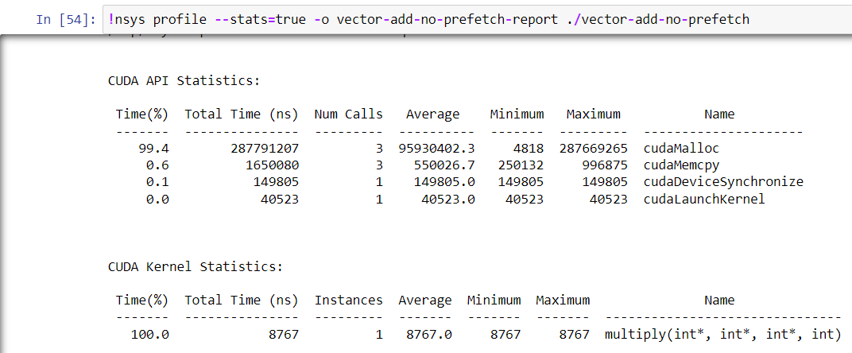

1. <<<1,128>>>

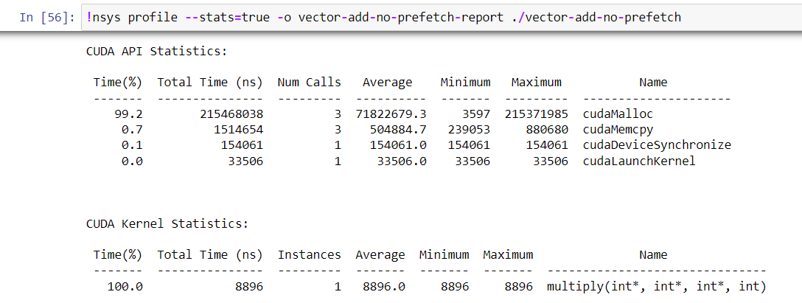

1. <<<1,256>>>

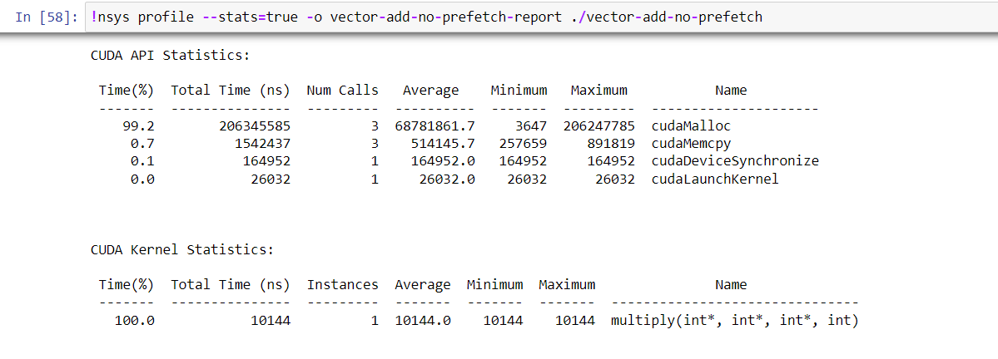

1. <<<2,128>>>

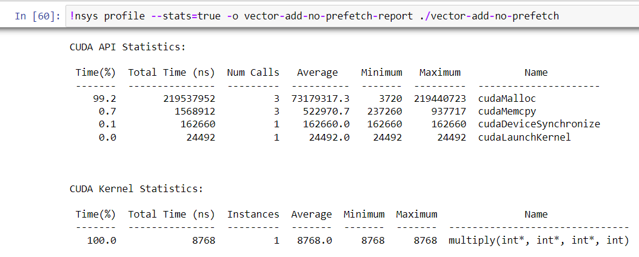

**Analysis:**

**Problem Statement 3:**

Implement Prefix sum using CUDA C. Analyze and tune the program for getting maximum speed up. Do Profiling and state what part of the code takes the huge amount of time to execute.

**Screenshots:**

1. Block Size: 64

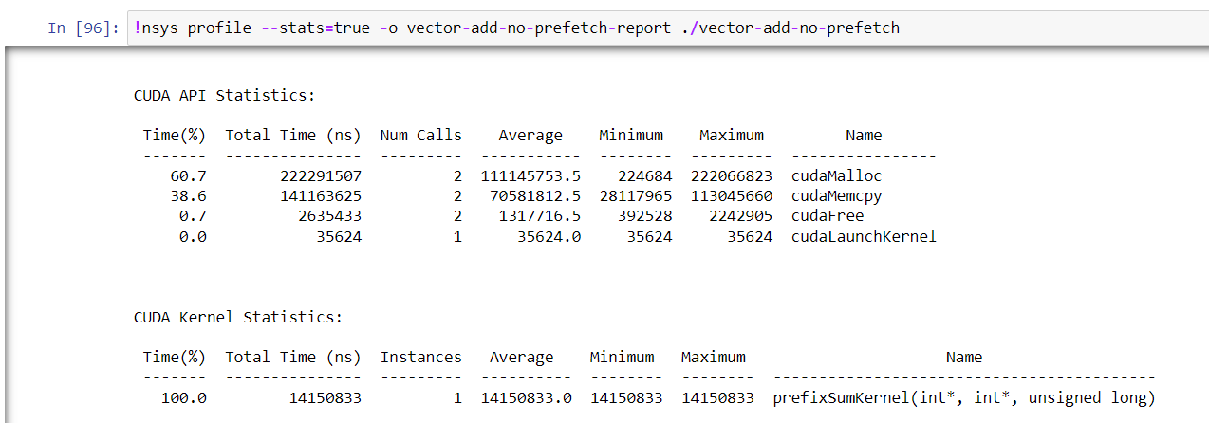

1. Block Size: 128

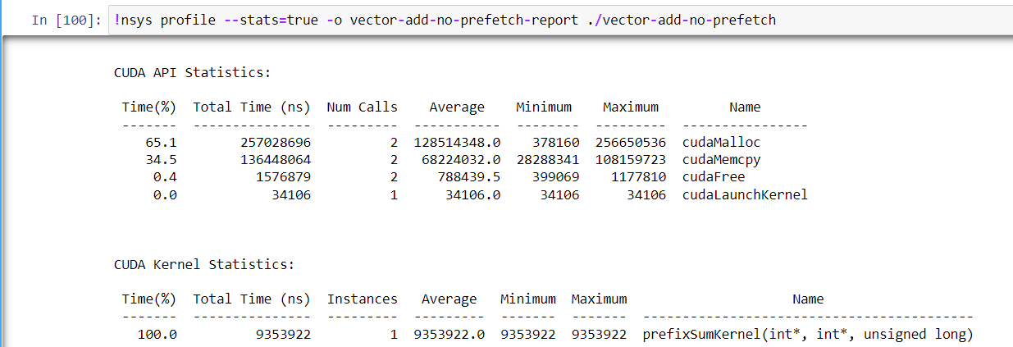

1. Block Size: 256

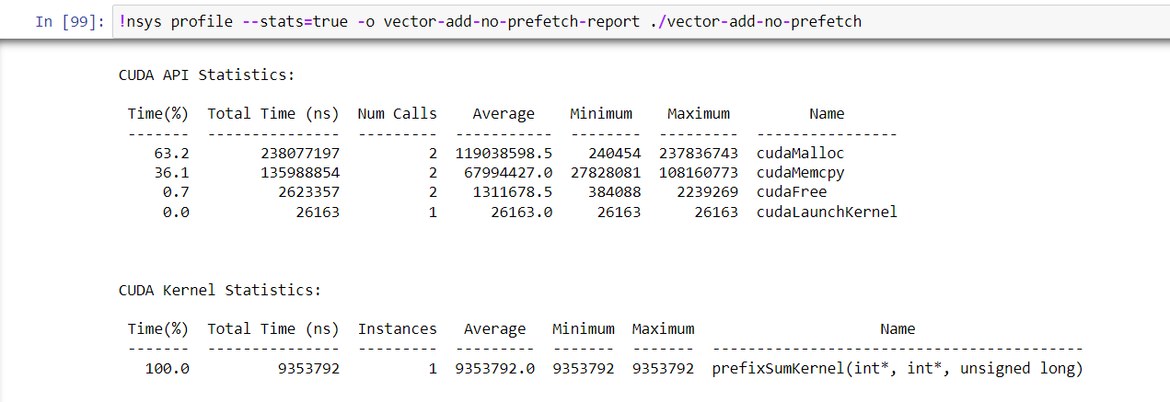

1. Block Size: 512

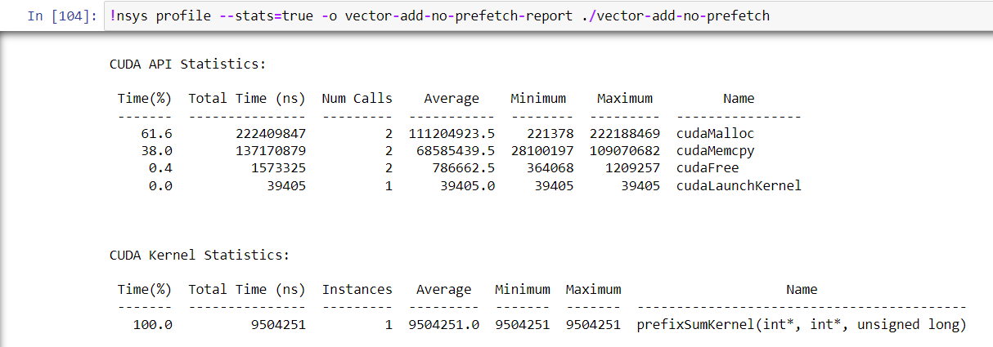

**Analysis:**

**Problem Statement 4:**

Implement 2D Convolution using shared memory using CUDA C. Analyze and tune the program for getting maximum speed up. Do Profiling and state what part of the code takes the huge amount of time to execute.

Image size: 256*256

Mask Size: 7*7

**Screenshots:**

1. 64 Threads

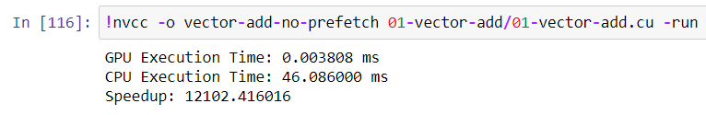

1. 128 Threads

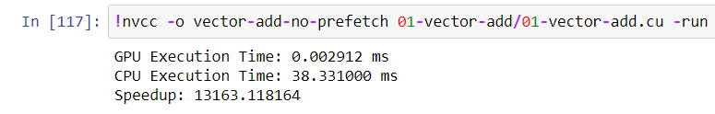

1. 256 Threads

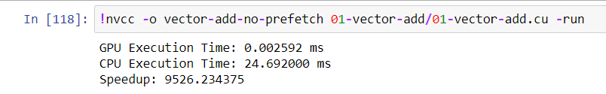

1. 512 Threads

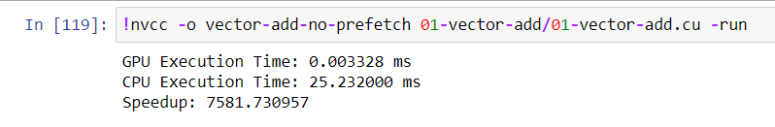

**GitHub:** <https://github.com/meetgandhi692/HPC-Lab/tree/7e35953168fb8ce9749ba75e07871908464ba1b1/Assignment%209>